**Calculator Application**

**Description:**

Calculator application is Windows Form based application where it allows to key in numbers and operate defined operations.

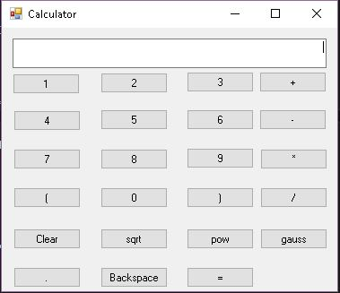

**Goals:**

1. BODMAS implemented
2. Added special functions like sqrt, pow and gauss function
3. Implemented with OOP and design pattern, so now, application is extensible for future changes

**Tools used:**

1. VS2012
2. Nunit 3.6 for Unit testing

**Application setup:**

1. Running exe is enough to launch the application.
2. Running application through VS2012